Introduction of GOES-16/ABI Flood Mapping Software

Version 1.0

Sanmei Li Donglian Sun

George Mason University

Email: [slia@gmu.edu](mailto:slia@gmu.edu)

Contents

Introduction of GOES-16/ABI Flood Mapping Software 1

1. Introduction 3

2. Algorithm description 3

2.1 ABI flood detection 3

2.2 ABI multiple composition 5

3. Module Description and Data flow 5

3.1 Module Description 5

3.1.1 Module 1: ABI_Flood_Detection_Version01 5

3.1.2 Module 2: ABI_Composition_Process 7

3.1.3 Module 3: Image Display 7

3.2 Data flow 7

3.2.1 Input 7

3.2.2 Output 8

4. Environment requirements 10

4.1 Source Codes: 10

4.2 System requirements: 10

4.3 Running time 10

5. Run modules 11

5.1 Run module: ABI_Flood_Detection_Version01 11

5.2 Run module: ABI_Composition_Process 11

5.3 Run module: Image Display 12

# Introduction

GOOES-16/ABI flood mapping software is designed for automatic flood detection in the CONUS or other regions covering by GOES-16/ABI using the Advanced Baseline Imager (ABI) data. The software consists of three modules: ABI_Flood_Detection module, ABI_Composition_Process module and Image Display module. With these three modules, the software projects ABI bands (C02, C03, C04, C05 and C13), static sensor zenith angle and static sensor azimuth angle in equidistant cylindrical projection, and then detects floods through a series of process to generate 5-minute or 10-minute flood detection result in HDF4 or netCDF4 formats. Based on the 5-minute or 10-minute flood datasets, the ABI_Composition_Process module aggregates the results through a rolling composition process to collect the maximal clear-sky coverage during an appointed period, and outputs composited results every hour in hdf4 or netCDF4 format. The Image_Display module displays flood detection result in png with a kml description file and geotiff formats.

The software is developed in C/C++ and IDL programming languages, and runs in 32-bit or 64-bit Linux system (recommended).

# Algorithm description

## ABI flood detection

The software utilizes a series of algorithms for flood automations. Figure 1 gives a simple sketch of algorithm flow chart. The algorithms are mainly adjusted from VIIRS flood detection algorithms with further improvements. Overall, these algorithms are combination of distance-based classification, decision-tree approach, change detection and thresholding method in addition to geometry-based cloud shadow removal and object-based terrain-shadow removal algorithms. Water fraction retrieval is also done by dividing water surface into non-sun-glint contaminated surface and sun-glint contaminated surface with different strategies. The details of these algorithms can be found in the following references:

* 1. Mitchell Goldberg, Sanmei Li, Steven Goodman, Dan Lindsey, Bill Sjoberg and Donglian Sun ( 2018). Contributions of Operational Satellites in Monitoring the Catastrophic Floodwaters Due to Hurricane Harvey, Remote Sens. 2018, 10(8), 1256
  2. SanmeiLi, DonglianSun, Mitchell Goldberg, Bill Sjoberg, David Santek, Jay P. Hoffman, Mike DeWeese, Pedro Restrepo, Scott Lindsey, Eric Holloway (2017). Automatic near real-time flood detection using Suomi-NPP/VIIRS data, Remote Sensing of Environment, 204 (2018) 672–689
  3. SanmeiLi, DonglianSun, Mitchell D.Goldberg & Bill Sjoberg (2015). Object-based automatic terrain shadow removal from SNPP/VIIRS flood maps, International Journal of Remote Sensing, Vol. 36, No. 21, 5504–5522
  4. SanmeiLi, DonglianSun, YunyueYu, Ivan Csiszar, Antony Stefanidis & Mitchell D. Goldberg (2012). A New Shortwave Infrared (SWIR) Method for Quantitative Water Fraction Derivation and Evaluation with EOS/MODIS and Landsat/TM data. IEEE Transactions on Geoscience and Remote Sensing, Vol. 51, Issue 3
  5. Sanmei Li, Donglian Sun & Yunyue Yu (2013). Automatic cloud-shadow removal from flood/standing water maps using MSG/SEVIRI imagery, International Journal of Remote Sensing, 34:15, 5487-5502
  6. Sanmei Li & Donglian Sun, 2013. Development of an integrated high resolution flood product with multi-source data, UMI Dissertations Publishing 2013, ISBN: 9781303635939, <http://search.proquest.com/docview/1492669000>, 2013
  7. DonglianSun, YunyueYu, RuiZhang, SanmeiLi, and Mitchel D. Goldberg (2012). Towards Operational Automatic Flood Detection Using EOS/MODIS data. Photogrammetric Engineering & Remote Sensing, 78 (6).



Figure 1 Algorithm flow chart of ABI Flood Detection Software

## ABI multiple composition

Because the final ABI flood product is a rolling composited result from multiple 5-minute ABI flood maps, a composition algorithm is used to collect the maximal clear-sky coverage with water, vegetation/bare land and snow/ice cover among all the observations. Any floodwater pixel in an ABI 5-minute flood map is assigned as a floodwater pixel and the maximal water fraction is chosen as the water fraction in the composited flood map. If the pixel is not a floodwater pixel in any 5-minute flood map, snow/ice cover is with the second priority for composition. If a pixel is with snow/ice cover in any 5-minute ABI flood map, then it is assigned as a snow/ice pixel and the status of snow or ice or mixed ice&water in the last ABI 5-minute flood map is used in the composited flood map. To filter some false detection from cloud shadow and snow/ice detection, the observation frequency of water, vegetation/bare land and clear-sky normal water, snow/ice cover and cloud cover, and the average floodwater fractions are also calculated. The composited datasets are further filtered by using two indices: $P_{w}$ and $P_{s}$ to decrease the false detection from cloud shadows and cloud cover.

$P_{w}=\frac{N_{w}}{N_{l}+N_{w}}$ (1)

$P_{s}=\frac{N_{s}}{N_{s}+N_{l}+N_{c}}$ (2)

Where, $P_{w}$: Probability of a floodwater pixel

$P_{s}$: Probability of a snow/ice pixel

$N_{w}$: observing frequency of floodwater

$N_{l}$: observing frequency of clear-sky land or normal water

$N_{s}$: observing frequency of snow/ice

$N_{c}$: observing frequency of cloud cover

If $P_{w}$ ≥ 0.3, it is defined as a floodwater pixel in the composited flood map, and is assigned with the average floodwater fraction, instead of the maximal water fraction.

If $P_{s}$ ≥ 0.1, it is defined as a snow/ice pixel in the composited flood map.

# Module Description and Data flow

## Module Description

### Module 1: ABI_Flood_Detection_Version01

ABI_Flood_Detection_Version01 Module is developed to project ABI CONUS or full-disk data including C02, C03, C04, C05, C13, static sensor zenith angle and static sensor azimuth angle in equidistant cylindrical projection at 1-km spatial resolution. The projection requires using a user-defined geographic text table (e.g. User_AOI_Definition.txt). Flood detection is then done based on the projected datasets using a series of ancillary datasets: 1-km land cover, 1-km DEM, 1-km land-sea mask, 1-km water reference map, sun-glint lookup table, pre-trained decision trees, 5-km albedo climatic datasets and 5-km LST and SST climatic datasets. Finally, the module outputs the detection results in hdf4 or netCDF4 format.

**Project in subsets according to users’ AOIs:** To project ABI data in the CONUS or full disk into subsets, the geographic range must be defined in a text file (e.g.User_AOI_Definition.txt) in the format shown in table 1.

Table 1 Format of user-define text file (User_AOI_Definition.txt)

|  |  |  |  |  |
| --- | --- | --- | --- | --- |
| **Region ID (int)** | **Min Longitude (float)** | **Max Longitude (float)** | **Min Latitude (float)** | **Max Latitude (float)** |
| 001 | -125.0 | -65.0 | 24.5 | 50.5 |

Table 1 defines the geographic region of CONUS used in the routine ABI flood process. Note there are only two types of ABI netcdf4 files that can be projected: OR_ABI-L1b-RadC- (CONUS) and OR_ABI-L1b-RadF- (full disk). Files with prefix naming rules other than these two cannot be projected. The projection also requires static sensor zenith angles and sensor azimuth angles under the ancillary folder:

* goes16_75.2W_1kmgrid_satazm.dat: GOES-16/ABI full-disk sensor azimuth angle file with nominal longitude 75.0°W:
* goes16_75.2W_1kmgrid_satzen.dat: GOES-16/ABI full-disk sensor zenith angle file with nominal longitude 75.0°W:
* goes16_75.2W_conus_1kmgrid_satazm.dat: GOES-16/ABI CONUS sensor azimuth angle file with nominal longitude 75.0°W:
* goes16_75.2W_conus_1kmgrid_satzen.dat: GOES-16/ABI CONUS sensor zenith angle file with nominal longitude 75.0°W:

If the data is with nominal sub-longitude 89.5°W, then the module uses the following view angles under the ancillary folder:

* goes16_89.5W_1kmgrid_satazm.dat: GOES-16/ABI full-disk sensor azimuth angle file with nominal longitude 89.5°W.
* goes16_89.5W_1kmgrid_satzen.dat: GOES-16/ABI full-disk sensor zenith angle file with nominal longitude 89.5°W:
* goes16_89.5W_conus_1kmgrid_satazm.dat: GOES-16/ABI CONUS sensor azimuth angle file with nominal longitude 89.5°W:
* goes16_89.5W_conus_1kmgrid_satzen.dat: GOES-16/ABI CONUS sensor zenith angle file with nominal longitude 89.5°W:

There are several situations that the module doesn’t do any projection:

* Night-time data
* Data outside of the geographic range of the ABI tiles.

**ABI flood detection:** Based on the projected datasets, flood detection is done with the following ancillary datasets under the ancillary folder:

Global_land_cover_IGBP_2017_USGS_types.raw

ABI_WEST_MOD44W_Water_Mask_30mlandcover.raw

Global_DEM_1km_NOAA_36000_18000.raw

lw_geo_2001001_v03m_1km.raw

Sun_Gliter_mask_005.dat

SST and LST climatology datasets

Albedo climatology datasets in the visible band.

All the process errors are recorded in the log file under the log file path: GOES_ABI_data_projection.txt.

### Module 2: ABI_Composition_Process

This module is to do hourly composition or daily composition on the ABI 5-m or 10-m flood datasets. For the hourly composition, the module composites 5-minute or 10-minute ABI flood datasets from the first available flood map to the appointed flood map which is input as a module parameter on the same day into one flood dataset by collecting the maximal clear-sky coverage in the composited flood map. For the daily composition, the module composites all the 5-minute or 10-minute ABI flood datasets in a day into one flood dataset by collecting the maximal clear-sky coverage in the composited flood map.

The module uses three ancillary datasets:

ABI_WEST_MOD44W_Water_Mask_30mlandcover.raw

lw_geo_2001001_v03m_1km.raw

Global_DEM_1km_NOAA_36000_18000.raw

All the process errors are recorded in the log file under the log file path: ABI_Composite_log.txt

### Module 3: Image Display

This module is developed in IDL to display ABI flood detection result in png with a kml description file and geotiff format.

IDL_ABI_WaterMap.pro: to generate ABI flood detection images in png and geotiff formats.

## Data flow

### Input

ABI Flood Detection software requires both real-time ABI data input and static ancillary data inputs.

* **ABI real-time Bands (must-have):**
  + C02 (spatial resolution: 500m), C03 (spatial resolution: 1-km), C04 (spatial resolution: 2-km), C05 (spatial resolution: 1-km), C13 (spatial resolution: 2-km)
* **ABI static sensor angles (must-have):**
  + Sensor zenith angle and sensor azimuth angle with sub-nominal longitude 89.5°W and 75.2°W

The static ancillary data inputs are listed in table 2.

Table 2 Static ancillary data inputs of ABI flood mapping software

|  |  |  |  |
| --- | --- | --- | --- |
| **Filename** | **Description** | **Used in modules** | **Format** |
| Global_land_cover_IGBP_2017_USGS_types.raw | Global 1-km land cover | ABI_Flood_Detection_Version01 | raw |
| Global_DEM_1km_NOAA_36000_18000.raw | Global 1-km Digital Elevation Model | ABI_Flood_Detection_Version01 | raw |
| lw_geo_2001001_v03m_1km.raw | Global 1-km land/sea mask | ABI_Flood_Detection_Version01  ABI_Composition_Process | raw |
| ABI_WEST_MOD44W_Water_Mask_30mlandcover.raw | 1-km water mask in west hemisphere | ABI_Flood_Detection_Version01  ABI_Composition_Process | raw |
| AQUA_Daytime_LST_SST_Climatology***.raw  TERRA_Daytime_LST_SST_Climatology***.raw (*** means julian day) | 5-km Land/sea surface temperature 16-day climatology | ABI_Flood_Detection_Version01 | raw |
| CMG-SMT-P0B1_ch1_**.raw (** means month from 01 to 12) | 5-km Global Albedo monthly climatology | ABI_Flood_Detection_Version01 | raw |
| Sun_Gliter_mask_005.dat | Sun-glint look-up table | ABI_Flood_Detection_Version01 | raw |
| Pre-trained decision tress and tree attribute files: e.g. Tree1_J48graft_water_cloud_vegetation_bareland_wetland_MODIS.txt | Pre-trained decision tress and tree attribute files | ABI_Flood_Detection_Version01 | text |
| User AOI definition file: e.g. User_AOI_Definition.txt | User AOI geographic definition file | ABI_Flood_Detection_Version01 | text |

### Output

The final outputs include 5-minute or 10-minute flood detection datasets and composited flood datasets (both in hdf4or netCDF format) and flood detection images in png, geotiff and kmz formats.

* **ABI 5-minute or 10-minute flood detection data**: WaterDetection. 16-bit short data type in hdf4 format, or 8-bit unsigned char data type in netCDF4 format
* **ABI composited flood detection data**: WaterDetection. 16-bit short data type in hdf4 format or 8-bit unsigned char data type in netCDF4 format
* **ABI flood detection images in png and geotiff formats**: the flood detection images are 8-bit one channel color-index png with a kml description file and geotiff images.
* **Logfile**: GOES_ABI_data_projection.txt which is generated by ABI_Flood_Detection_Version01 Module and ABI_Composite_log.txt which is generated by ABI_Composition_Process Module. Both the two log files are used to record the errors during flood detection and composition process.

**1) Naming rule of the ABI 5-minute flood detection dataset**

The naming rule of ABI 5-minute flood detection dataset is:

*WATER_MMM_ABI_YYYYMMDD_YYYYJJJ_HHMMSSS_col_row_a subset of date and time information from the original ABI C02 file with prefix c_regionID.hdf (.nc)*

For example, with a C02 file:

*OR_ABI-L1b-RadC-M3C02_G16_s20172431932151_e20172431934523_c20172431934560.nc*

The produced 5-minute ABI flood detection dataset in the CONUS defined by table 1 is with the name:

*WATER_G16_ABI_20170831_2017243_1933030_6000_2600_20172431934560_001.hdf*

*Or,*

*WATER_G16_ABI_20170831_2017243_1933030_6000_2600_20172431934560_001.nc*

**2) Naming rule of the ABI hourly composited flood detection dataset**

The naming rule of ABI hourly composited flood detection dataset is:

*COM_MMM_ABI_WATER_YYYYMMDD_YYYYJJJ_HHMM(Beginning)_HHMM(end)_col_row_N(number_of_total_5-minute_ABI_files)_regionID.hdf (.nc)*

*MMM* represents satellite name. For GOES-16, MMM uses G16, and for GOES-17, MMM uses G17.

For example, the hourly composited flood dataset from 14:03 to 15:08 (UTC) is with the name:

*COM_G16_ABI_WATER_20170831_2017243_1403_1508_6000_2600_13_001.hdf*

*Or,*

*COM_G16_ABI_WATER_20170831_2017243_1403_1508_6000_2600_13_001.nc*

**3) Naming rule of the ABI daily composited flood detection dataset**

The naming rule of ABI daily composited flood detection dataset is:

*COM_MMM_ABI_WATER_YYYYMMDD_YYYYJJJ_col_row_regionID.hdf (.nc)*

*MMM* represents satellite name. For GOES-16, MMM uses G16, and for GOES-17, MMM uses G17.

For example, the daily ABI composited flood dataset on Aug. 31, 2017 is:

*COM_G16_ABI_WATER_20170831_2017243_6000_2600_001.hdf*

Or,

*COM_G16_ABI_WATER_20170831_2017243_6000_2600_001.nc*

The images keep the same name rules of the corresponding files, and the suffixes are *.png*, or *.tif*, or *.kml*.

Figure 2 presents a data flow chart of ABI Flood Mapping Software.



Figure 2 Data flow chart of ABI Flood Mapping Software

# Environment requirements

## Source Codes:

**ABI_Flood_Detection_Version01 and ABI_Composition_Process** modules are writtenin C/C++.

**Image_Display module** is written in IDL.

## System requirements:

The software is recommended to run in Linux 64-bit system with at least 4GB memory. It can also be run in Linux 32-bit system with at least 4GB memory.

To compile, build and run the software, the **GNU Compiler Collection** including GCC/GCC C++, and IDL (license is required) are required.

## Running time

Running time depends on the region size and flooding situation. For example, it takes about 4-8 minutes to finish one 5-minute tile in the CONUS.

# Run modules

## Run module: ABI_Flood_Detection_Version01

The parameters to run ABI_Flood_Detection_Version01include:

* **-h:** [Necessary], file path ABI real-time netCDF files
* **-b:** [Necessary], filename of a ABI M3C02 netCDF file to be processed
* **-a:** [Necessary], file path of the ancillary data.
* **-o:** [Necessary], file path of the output hdf4 results
* **-l:** [Necessary], file path of the log file,
* **-u**: [Necessary], filename of user-defined geographic range txt file
* **-p**: [Necessary], file path of user-defined geographic range txt file
* **-f**: [Necessary], output data format: 1, hdf4; 2, netCDF4

To run the executive module: ABI_Flood_Detection_Version01 with file in the CONUS defined by table 1:

*OR_ABI-L1b-RadC-M3C02_G16_s20172431932151_e20172431934523_c20172431934560.nc*, the test script is written as:

*./ABI_Flood_Detection_Version01 -h /ABI_data -b OR_ABI-L1b-RadC-M3C02_G16_s20172431932151_e20172431934523_c20172431934560.nc -a /assdata/global -o /ABI_data/output -l /logfile -p / angles -u User_AOI_Definition.txt –f 1*

This produces a 5-minute flood dataset under the */ABI_data/output*:

*WATER_ABI_20170831_2017243_1933030_6000_2600_20172431934560_001.hdf*

## Run module: ABI_Composition_Process

There are four parameters:

* **-h**: **[Necessary]**, file path of ABI 5-minute flood datasets to be composited
* **-a**: **[Necessary]**, file path of the ancillary datasets
* **-v**: **[Necessary]**, filename of the latest ABI 5-minute flood dataset to be composited for hourly composition or filename of any ABI 5-minute flood dataset on the same day to be composited for daily composition
* **-o**: **[Necessary]**, file path of the output GEO composited results
* **-l: [Necessary],** file path of the log file
* **-n: [Necessary],** composition type: 0, hourly composition; 1, daily composition
* **-f: [Necessary],** output data format: 1, hdf4; 2, netCDF4

To run the executive module ABI_Composition_Processendingwith data for hourly compostion:

*WATER_ABI_20170831_2017243_2258030_6000_2600_20172432259557_001.hdf*

The test script is written as:

*./ABI_Composition_Process -h /ABI_data -v WATER_ABI_20170831_2017243_2258030_6000_2600_20172432259557_001.hdf -a /assdata/global* -*o /ABI_data/output -l /logfile –n 0 –f 1*

This produces a composited file under the folder */ABI_data/output* by assuming you have 83 5-minute flood dataset in hdf4 format with the first one starting at 13:23 under the same folder:

*COM_ABI_WATER_20170831_2017243_1323_2103_6000_2600_83_001.hdf*

To run the executive module ABI_Composition_Processendingwith data for daily compostion:

*WATER_ABI_20170831_2017243_2258030_6000_2600_20172432259557_001.hdf*

The test script is written as:

*./ABI_Composition_Process -h /ABI_data -v WATER_ABI_20170831_2017243_2258030_6000_2600_20172432259557_001.hdf -a /assdata/global* -*o /ABI_data/output -l /logfile –n 1-f 1*

This produces a daily composited file under the folder */ABI_data/output* using all the ABI 5-minute files on the same day:

*COM_ABI_WATER_20170831_2017243_6000_2600_001.hdf*

## Run module: Image Display

Before compile the IDL procedure: *IDL_ABI_WaterMap.pro*, make sure IDL is installed and IDL_Path is added to ${path}. Then copy the procedure in a directory, and add the directory path to ${path} too.

Under IDL run-time environment, compile the two procedures:

*IDL>.compile IDL_ABI_WaterMap.pro*

There are three parameters to run *IDL_ABI_WaterMap.pro*:

*Inpath*: file path to VIIRS calibrated projected SDR data

*Outpath*: file path to output generated images

*Keywords*: keywords of the appointed flood datasets, e.g. *.hdf or WATER*.hdf

To run IDL_ABI_WaterMap.pro in IDL run-time environment:

*IDL>.compile IDL_ABI_WaterMap.pro*

*IDL> IDL_ABI_WaterMap, Inpath, Outpath, keywords*

It will generate ABI 5-minute or composited flood maps in the Outpath folder including three files:

*.png, *.kml and *.tif.

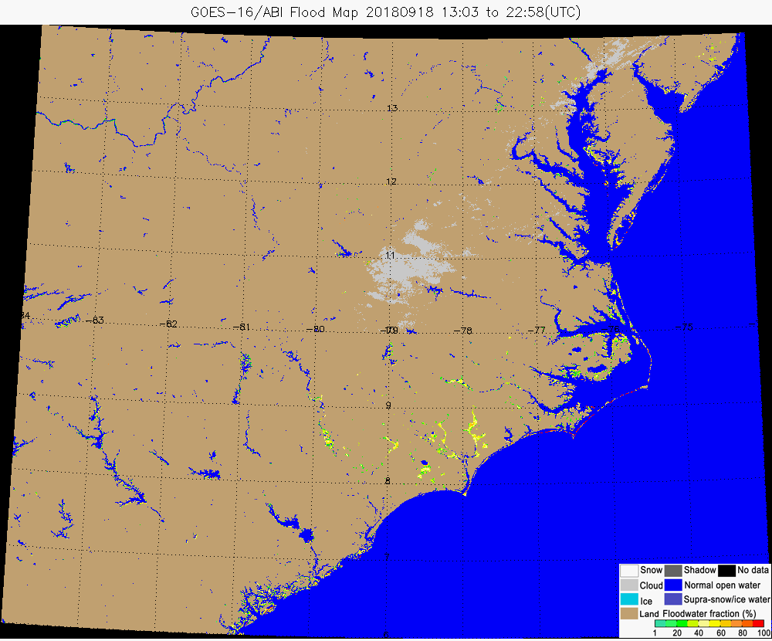

Figure 3 An example of ABI composited flood map from 13:03 to 22:58 (UTC) on Sep. 18, 2018 in the southeast of USA due to hurricane Florence